**Task 1 Canvas 35 MARKS**

**Instructions**

1. Create an HTML file named canvas.html. Based on using HTML5, define a canvas element with the following properties:

Width: 500px

Height: 500px

Border: “DarkGreen”, solid, 12px.

(3 marks)

2. Write a java-script function to draw a square with following properties:

Size: 460x460

Fill colour: #CC99FF

The square should be exactly in the middle of the canvas. Please see an example in the next page.

(3 marks)

3. Write a java-script function to draw a circle with following properties:

fill colour: #33FF99

border: black, 4px.

The circle will be a frog head. It should be exactly in the middle of the canvas. Please see an example in the next page.

(3 marks)

4. Write a java-script function to draw a circle with following properties:

fill colour: #33FF99

border: black, 4px.

The circle will be a frog body. It should be exactly in the middle of your canvas.

(3 marks)

5. Write a java-script function to draw two squares with the following properties:

Size: 45px X 85px,

fill colour: #009966.

The squares will be the frog legs. They should be attached to the body of the frog.

(4 marks)

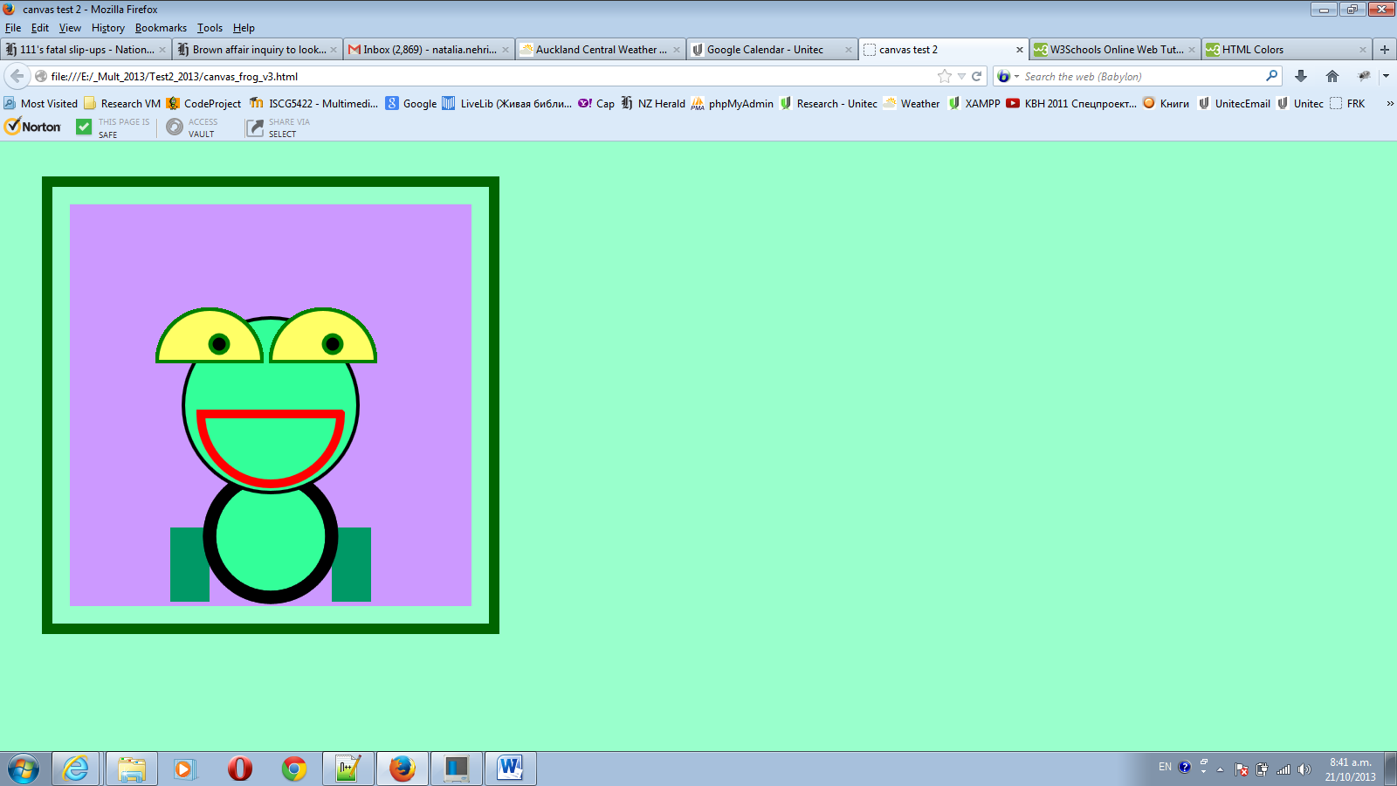

Yellow, #FFFF66

black

black

#CC99FF

Red,

Green

#009966

Green, #33FF99

6. Write a java-script function to draw a red semi-circle with the following properties:

Radius: 80

Border: 10px, strokeStyle: "red".

The semi-circle represents a mouth of the frog.

(4 marks)

6. Write a java-script function to draw two yellow semi-circles with the following properties:

fill colour: #2A75B6.

The semi circles represent eyes of the frog. Write a java-script function to draw two black circles with green borders.

(4marks)

5. Write a java-script function to move eyes. The two black middle-eyes shouldn’t go out of the yellow eyes area. Set interval (timer) for every 180 milli seconds for their movement.

(11 marks)